***Square silk scarf***

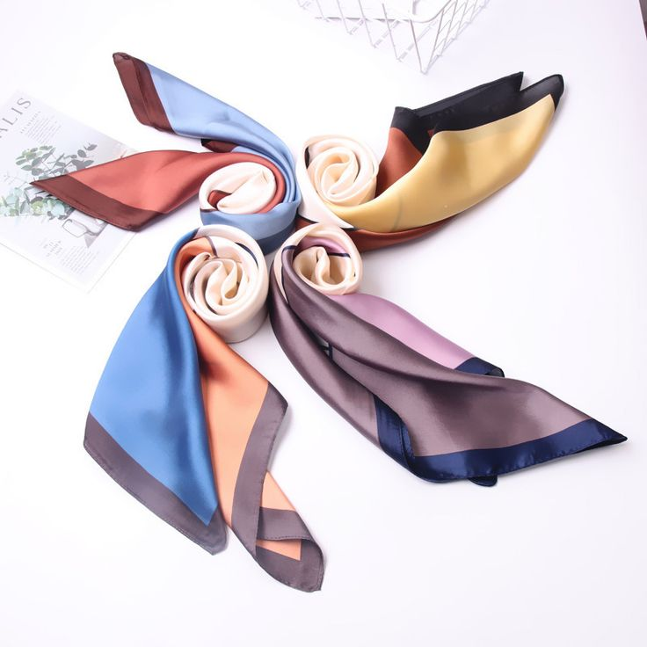

*The soft silk scarf will make your outfit more luxurious and elegant. Simple and elegant motifs will create accents, helping you look successful but still very sweet and never out of fashion.*